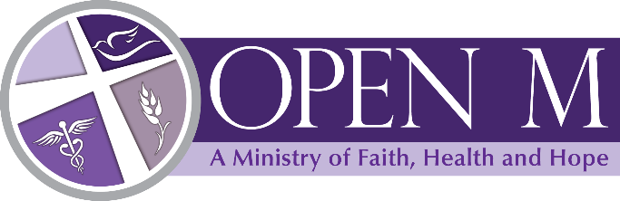
COVID-19 UPDATE

Our pantry and food programs will continue but will be modified to meet health and safety standards.
If you have any questions please feel free to call us at (330) 434-0110.

